NAAN MUDHALVAN

POLITICAL JUGGERNAUTS A QUANTITATIVE ANALYSIS OF CANDIDATES

( LOK SABHA ANALYSIS – 2019 )

PROJECT REPORT

FACULTY NAME

Mr. Sakthivel

|  |  |  |  |
| --- | --- | --- | --- |
| S.NO | NAME | IN TEAM  ROLE | NM ID |
| 1. | M.SURESH | HEAD | B954FB8486E7B42A12C4F127D7D76A47 |
| 2. | S.VINISH | MEMBER | AEFE59A0295C6589B68460640CF42650 |
| 3. | U.SIVAPANDIYAN | MEMBER | EE78D5A1318439782D24E35768C17A51 |
| 4. | S.TAMILARASAN | MEMBER | D7E7124537B35C9B82C4660109B11D38 |

PG.NO

1. INTRODUCTION
   1. Overview …………………………………………... 3
   2. Purpose …………………………………………….. 3
2. PROBLEM DEFINITION & DESIGN THINKING
   1. Empathy map screenshot ……………………….. 5
   2. Ideation & Brainstorming Map screenshot....…… 6
3. RESULT ………………………………………………….. 7
4. ADVANTAGES & DISADVANTAGES …………... 8
5. APPLICATIONS ………………………………………….. 12
6. CONCLUSION …………………………………………… 14

1. FUTURE SCOPE ………………………………………. 17
2. APPENDIX ……………………………………………… 18

1. INTRODUCTION

**1.1 OVERVIEW**

**Political Juggernauts: A Quantitative Analysis of Candidates in the 2019 Lok Sabha Elections :**

The Lok Sabha is composed of representatives of people chosen by direct election on the basis of Universal Adult Suffrage. The Constitution of India allows for a maximum of 550 members in the House, with 530 members representing the States and 20 representing the Union Territories. The 17th Lok Sabha was formed by the members elected in the 2019 Indian general election. Elections, all across India, were conducted in seven phases from 11 April 2019 to 19 May 2019 by the Election Commission of India. The Bharatiya Janata Party received 37.36% of the vote, the highest vote share by a political party since the 1989 general election, and won 303 seats, further increasing its substantial majority. In addition, the BJP-led National Democratic Alliance (NDA) won 353 seats.

**1.2 PURPOSE**

To analyze the winners and total voters and electors and Postal Votes of Lok Sabha, and criminal Cases in Each State & Party. In which State There are more winners and which party got more seats and liabilities and assets of each state.

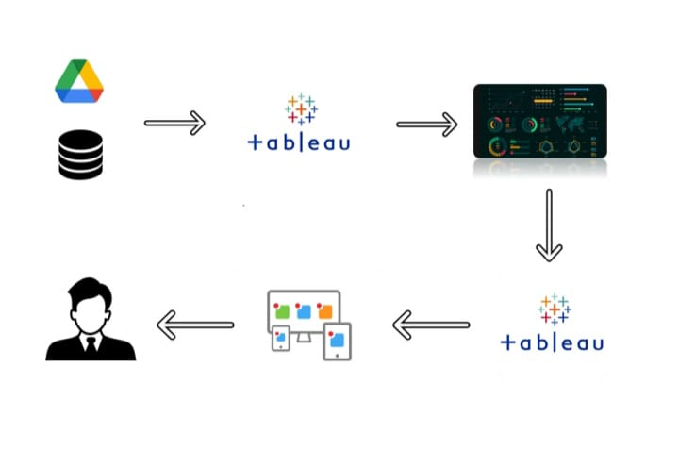

2. PROBLEM DEFINITION & DESIGN THINKING

The problem statement for a Lok Sabha analysis 2019 data project involves identifying the primary challenges, objectives, and questions that the analysis aims to address through the examination of data related to the 2019 Indian Lok Sabha elections.

**Problem Statement:**

The Lok Sabha analysis 2019 data project seeks to comprehensively analyze and derive insights from the diverse dataset encompassing the 2019 Indian Lok Sabha elections.To gather, clean, and integrate a wide range of data sources, including election results, candidate profiles, voter demographics, constituency information, and historical election data, into a unified and structured dataset suitable for analysis. To investigate and understand voting patterns, preferences, and demographics of the electorate during the 2019 Lok Sabha elections. This analysis should include factors influencing voter choices and voter turnout. To provide a detailed analysis of individual Lok Sabha constituencies, including candidate performance, margins of victory, and voter turnout, allowing for a granular understanding of election outcomes.To contextualize the 2019 elections by comparing the data with previous Lok Sabha elections, identifying shifts, trends, and changes in political dynamics over time.To visualize election results on maps, highlighting regional variations, political hotspots, and key battleground areas, aiding in the geographic understanding of voting patterns.

**2.1 EMPATHY MAP**

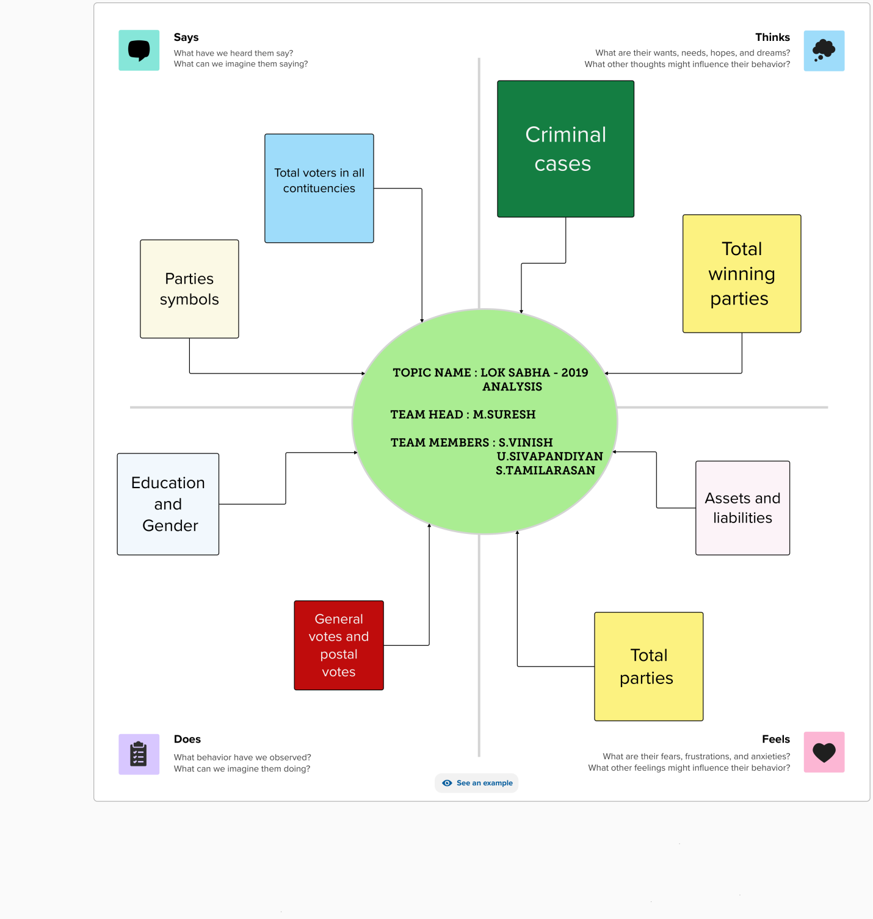

**2.2 IDEATION & BRAINSTORMING MAP**

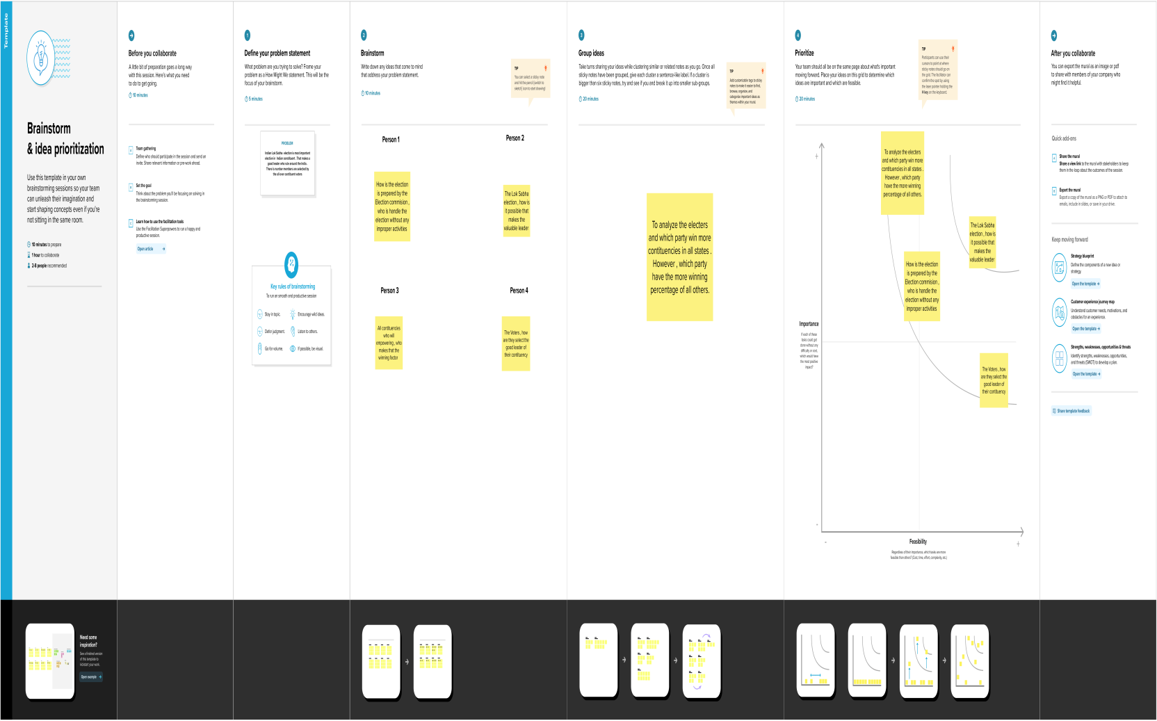

**3. RESULT**

The process of creating graphical representations of data in order to help people understand and explore the information. The goal of data visualization is to make complex data sets more accessible, intuitive, and easier to interpret. By using visual elements such as charts, graphs, and maps, data visualizations can help people quickly identify patterns, trends, and outliers in the data.

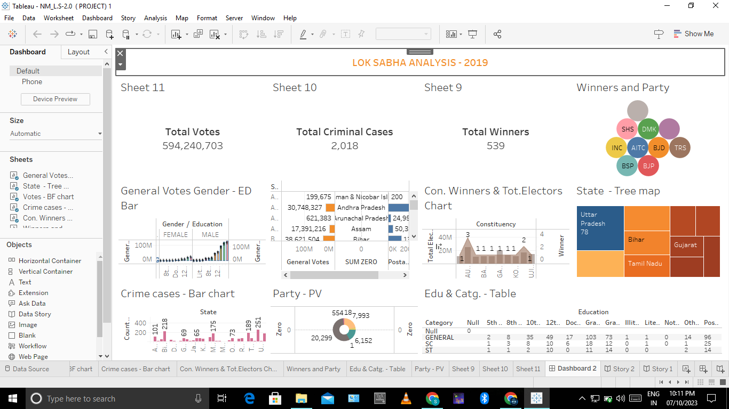

**4. ADVANTAGES**

**1. DATA TRANSPARENCY :** Visualization can make complex political data more accessible and transparent to the public, enabling informed decision-making.

**2. CLARITY :** Visual representations of data can make it easier to understand trends, patterns, and key insights from the Lok Sabha elections.

**3. ACCESSIBILITY :** Visualizations can be designed to be easily accessible to a wide audience, including those with varying levels of data literacy.

**4. INTERACTIVITY** : Interactive visualizations can allow users to explore election data on their own, drilling down into specific regions, constituencies, or demographics.

**5. REAL-TIME UPDATES :**  If the visualization is updated in real-time, it can provide up-to-the-minute information on election results and trends.

**6. COMPARATIVE ANALYSIS :** Visualizations can facilitate comparisons between different Lok Sabha elections, helping to identify shifts in voter behavior and political landscapes.

**7. GEOSPATIAL INSIGHTS :** Maps and geospatial visualizations can provide insights into regional variations in election results, highlighting key battleground areas.

**8. DEMOGRAPHIC ANALYSIS :** Visualizations can break down election data by demographics, such as age, gender, and socioeconomic status, to reveal voting patterns.

**9. PREDICTIVE MODELING :** Advanced visualizations may incorporate predictive modeling techniques, allowing users to explore potential future scenarios based on historical data.

**10. ENGAGEMENT :** Visualizations can engage the public and encourage civic participation by making election data more interesting and informative.

**11. DATA-DRIVEN DECISION-MAKING :** Policymakers and political strategists can use visualizations to inform their decisions and strategies for future elections.

**12. STORYTELLING** : Visualizations can tell a compelling and data-driven story about the Lok Sabha elections, helping to communicate key messages and narratives.

**13. EDUCATIONAL TOOL :** Visualizations can serve as educational tools in schools and universities, helping students understand the electoral process and political dynamics.

**14. ACCOUNTABILITY :** By making election data more accessible, visualizations can promote accountability and transparency in the political process.

**15. MEDIA COVERAGE :** Journalists and media organizations can use visualizations to enhance their election coverage, providing viewers with a more comprehensive understanding of the results.

DISADVANTAGES

**1. DATA QUALITY ISSUES :** If the data used for the visualization is incomplete, inaccurate, or biased, it can lead to misleading insights and conclusions.

**2. DATA PRIVACY CONCERNS :** Handling sensitive political and personal data must adhere to strict privacy regulations and ethical guidelines. Violations can lead to legal and ethical problems.

**3. COMPLEXITY :** Creating meaningful visualizations from complex political data can be challenging. If not done correctly, the visualizations may confuse rather than clarify.

**4. LACK OF CONTEXT :** Visualizations may not provide sufficient context or explanations, making it difficult for users to understand the significance of the data and its implications.

**5. MISINTERPRETATION :** Users may misinterpret visualizations, leading to incorrect conclusions or misunderstandings about election results.

**6. LIMITED ACCESSIBILITY :** If the visualization is not designed with accessibility in mind, it may exclude individuals with disabilities, violating accessibility standards.

**7. BIAS IN VISUALIZATION :** The design choices made in creating the visualization (e.g., color schemes, chart types) can introduce unintentional bias, affecting the perception of the data.

**8. OUTDATED INFORMATION :** If the visualization is not updated regularly, it may become irrelevant as new data and election results become available.

**9. TECHNOLOGY CONSTRAINTS :** Depending on the chosen technology stack, the visualization may have limitations in terms of scalability, interactivity, or compatibility with certain devices and browsers.

**10. DATA OVERLOAD :** Overly complex or cluttered visualizations can overwhelm users with too much information, reducing the effectiveness of the analysis.

**11. CONFIRMATION BIAS :** Users may selectively interpret the visualization to confirm pre-existing beliefs or biases, rather than seeking objective insights.

**12. SECURITY RISKS :** If the visualization project involves sensitive data or is hosted on a public server, it could be vulnerable to security breaches or cyber attacks.

**13. COSTS :** Developing and maintaining a comprehensive visualization project can be costly in terms of software, hardware, and human resources.

**14. RESOURCE CONSTRAINTS :** Limited access to skilled data analysts, designers, or developers can hinder the quality and effectiveness of the visualization.

**15. ETHICAL CONSIDERATIONS :** Political analysis visualizations must be created with a strong sense of ethics, avoiding any attempts to manipulate or distort data for political gain.

**5. APPLICATIONS**

**1. ELECTION CAMPAIGN STRATEGY :** Political parties and candidates can use the visualization to understand voting patterns, demographics, and trends in specific constituencies to develop more effective campaign strategies.

**2. MEDIA AND JOURNALISM :** Journalists and media organizations can use the visualization to provide in-depth and interactive coverage of the 2019 Lok Sabha elections, offering their audience a better understanding of election results and dynamics.

**3. GOVERNMENT AND POLICY ANALYSIS :** Government agencies and policymakers can use the visualization to assess the impact of policies and decisions on election outcomes and to identify areas for policy improvement.

**4. ACADEMIC RESEARCH :** Researchers and academics can analyze the data visualizations to study voting behavior, political trends, and their implications for Indian politics.

**5. EDUCATIONAL TOOL :** Educational institutions can use the visualization as a teaching tool to educate students about the electoral process, Indian politics, and data analysis techniques.

**6. DATA JOURNALISM :** Data journalists can use the visualization to uncover and tell data-driven stories about the 2019 Lok Sabha elections, providing a deeper understanding of political events and outcomes.

**7. CONSTITUENCY-LEVEL ANALYSIS :** Individuals interested in a specific Lok Sabha constituency can use the visualization to explore election results, voter turnout, and candidate performance in that area.

**8. HISTORICAL COMPARISON :** Users can compare the 2019 Lok Sabha election data with data from previous elections to identify changes and trends in voting patterns and political dynamics.

**9. CIVIC ENGAGEMENT :** The visualization can be used to encourage civic engagement by providing citizens with transparent and accessible election data, helping them make informed decisions and participate in the political process.

10. **Media Organizations:** Media organizations can use the visualization to enhance their election coverage, providing viewers with interactive tools to explore election data in real-time.

**11. POLITICAL CAMPAIGNS :** Political parties and candidates can use the visualization to target their campaigns more effectively by identifying key issues and demographics in each constituency.

**12. EXIT POLL ANALYSIS :** The visualization can be used to compare exit poll predictions with actual election results, helping to assess the accuracy of pollsters and the impact of predictions on voter behavior.

**13. NGOS AND ADVOCACY GROUPS :** Non-governmental organizations and advocacy groups can use the visualization to analyze election outcomes and advocate for specific policies or reforms.

**14. INTERNATIONAL RELATIONS :** Foreign governments and international organizations may use the visualization to understand the political landscape in India and its potential implications for international relations.

**15. ELECTION COMMISSION :** The Election Commission of India can utilize visualization tools to analyze voter turnout, election security, and logistical challenges in different constituencies.

**16. CORPORATE AND MARKET ANALYSIS :** Businesses can analyze election data to understand potential impacts on markets and industries, helping them make informed business decisions.

6. CONCLUSION

**KEY FINDINGS AND CONTRIBUTIONS OF THIS VISUALIZATION PROJECT INCLUDE:**

**1. VOTER DEMOGRAPHICS :** The project analyzed voter demographics, revealing the age groups, gender, and socioeconomic backgrounds of voters. It provided a deeper understanding of who participated in the election.

**2. GEOSPATIAL INSIGHTS :** Geospatial visualizations highlighted regional variations in election results, emphasizing key battleground areas and illustrating the geographic distribution of political support.

**3. TRENDS AND PATTERNS :** By examining historical data and comparing it to the 2019 election results, the project identified trends and patterns in voting behavior. It allowed for a nuanced analysis of how political landscapes evolved over time.

**4. CONSTITUENCY-LEVEL ANALYSIS :** The project offered granular insights into individual Lok Sabha constituencies, providing information about candidate performance, voter turnout, and the issues that influenced the outcomes.

**5. INTERACTIVE EXPLORATION :** The visualization allowed users to interact with the data, enabling them to drill down into specific regions, demographics, and election-related details. Users could explore data based on their interests and questions.

**6. EDUCATIONAL TOOL :** As an educational resource, the visualization served as a valuable tool for students, researchers, and the general public, fostering a better understanding of the Indian electoral system.

**7. CIVIC ENGAGEMENT :** By making election data more accessible and transparent, the project promoted civic engagement. It empowered citizens to make informed decisions, participate in the political process, and hold elected officials accountable.

**8. MEDIA COVERAGE :** The visualization enhanced media coverage of the Lok Sabha elections, providing journalists with powerful tools to convey election results and trends to their audiences.

**9. DATA-DRIVEN DECISION-MAKING :** Policymakers, political parties, and campaign strategists could use the insights gained from the visualization to inform their decisions and strategies for future elections.

**10. HISTORICAL PERSPECTIVE :** Through historical comparisons, the project offered a context for understanding the 2019 election within the broader context of Indian politics.

In conclusion, the Lok Sabha analysis 2019 visualization project provided a valuable platform for analyzing and understanding the 2019 Lok Sabha elections in India. It offered insights, transparency, and interactivity, contributing to informed decision-making, political analysis, and public engagement. This project exemplifies the power of data visualization in illuminating complex political processes and encouraging active participation in the democratic process. It serves as a model for future efforts to analyze and visualize electoral data, contributing to a more informed and engaged citizenry.

7. FUTURE SCOPE

**1. REAL-TIME UPDATES :** Provide real-time or near-real-time updates to the visualization to reflect any post-election developments, such as by-elections, policy changes, or shifts in political dynamics.

**2. USER PERSONALIZATION :** Allow users to personalize their experience by saving preferences, creating custom dashboards, and receiving tailored insights based on their interests and demographics.

**3. PREDICTIVE MODELING :** Incorporate predictive modeling and scenario analysis to help users understand the potential impact of different factors on future elections.

**4. MACHINE LEARNING INTEGRATION :** Implement machine learning algorithms to identify hidden patterns and correlations in the data, providing more sophisticated insights.

**5. SENTIMENT ANALYSIS :** Integrate sentiment analysis of social media and news data to gauge public sentiment and its potential influence on election outcomes.

**6. DATA AGGREGATION :** Expand data sources to include a wider range of information, such as exit polls, opinion surveys, and socioeconomic indicators, to provide a more comprehensive view of the elections.

**7. MOBILE OPTIMIZATION :** Ensure the visualization is mobile-friendly and responsive to cater to users who access it on smart phones and tablets.

**8. ACCESSIBILITY :** Implement accessibility features to make the visualization usable by individuals with disabilities, adhering to accessibility standards.

**9. MULTI-LANGUAGE SUPPORT :** Offer support for multiple languages to reach a broader audience and accommodate non-English speakers.

**10. INTERACTIVE NARRATIVES :** Incorporate interactive storytelling elements that guide users through the visualization, helping them understand the context and significance of the data.

These enhancements can help keep the Lok Sabha analysis 2019 visualization project up-to-date, user-friendly, and relevant in the evolving landscape of political analysis and data visualization. They can also improve its utility for a wide range of stakeholders, including researchers, policymakers, journalists, and the general public.

8. APPENDIX